CREATE TABLE sales (  
    region VARCHAR2(50),  
    product VARCHAR2(50),  
    year NUMBER,  
    quarter NUMBER,  
    amount NUMBER  
);

INSERT INTO sales VALUES('North','Product A',2020,1,1000);  
INSERT INTO sales VALUES('North','Product B',2020,1,1500);  
INSERT INTO sales VALUES('North','Product A',2020,2,1200);  
INSERT INTO sales VALUES('North','Product B',2020,2,1800);  
INSERT INTO sales VALUES('South','Product A',2020,1,900);  
INSERT INTO sales VALUES('South','Product B',2020,1,1300);  
INSERT INTO sales VALUES('South','Product A',2020,2,1100);  
INSERT INTO sales VALUES('South','Product B',2020,2,1700);

COMMIT;

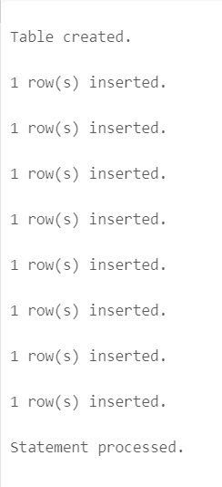

SELECT * FROM sales;

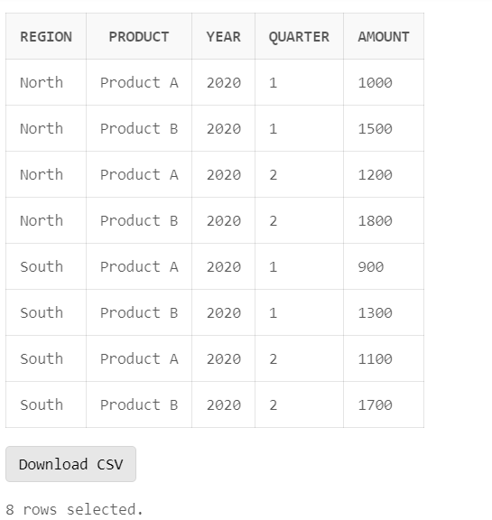

-- Slice  
SELECT * FROM sales WHERE region = 'North';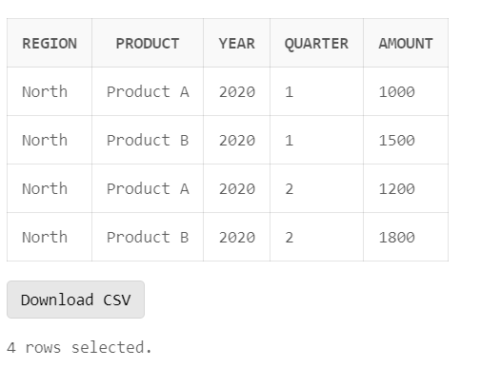

-- Dice  
SELECT * FROM sales WHERE region = 'North' AND product = 'Product A';

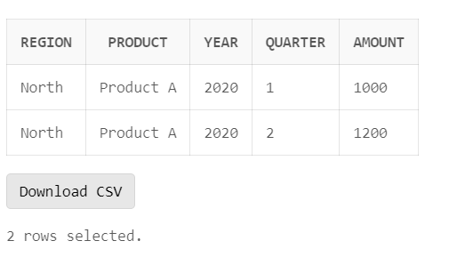

-- Drilldown (Roll Down)  
SELECT region, product, year, SUM(amount) AS total_amount FROM sales GROUP BY ROLLUP(region, product, year);  
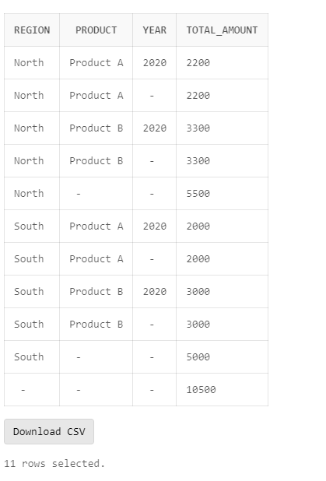

-- Rollup (Drill Up)  
SELECT region, product, SUM(amount) AS total_amount FROM sales GROUP BY ROLLUP(region, product);  
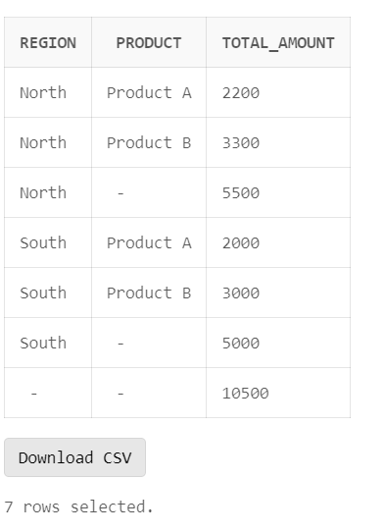

-- Pivot (Rotate)  
SELECT * FROM (  
    SELECT region , product, quarter, amount From sales  
)  
Pivot (  
    SUM(amount)  
    For quarter IN (1 AS Q1, 2 AS Q2)  
);

